Devops Day-9
1.Install Docker and verify installation using docker version and docker info.
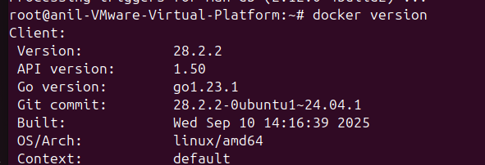
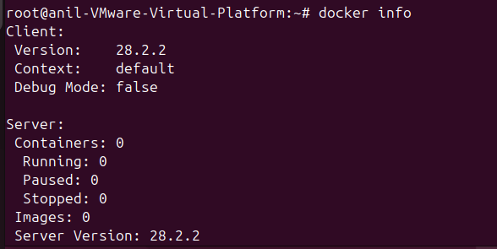
2.Create a simple application and understand its runtime requirements.
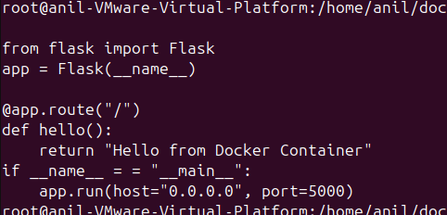
3.Write a Dockerfile defining base image, dependencies, working directory, and run command.
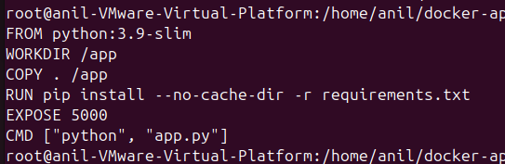
4.Build the Docker image using docker build and tag it properly.
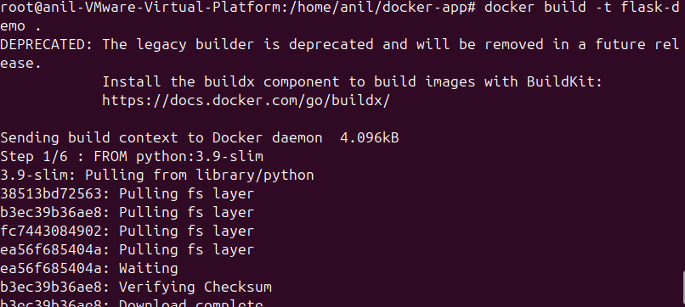
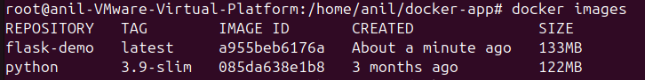
5.Run the container using docker run and expose necessary ports.
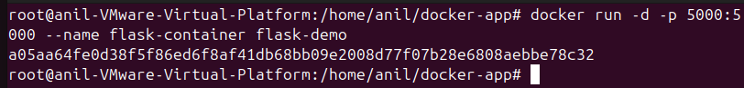
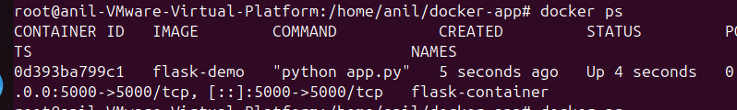
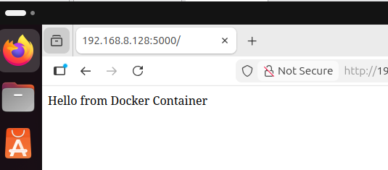
6.Inspect running containers and logs using Docker CLI commands.
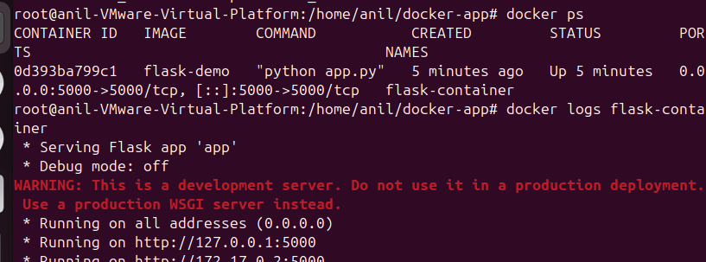
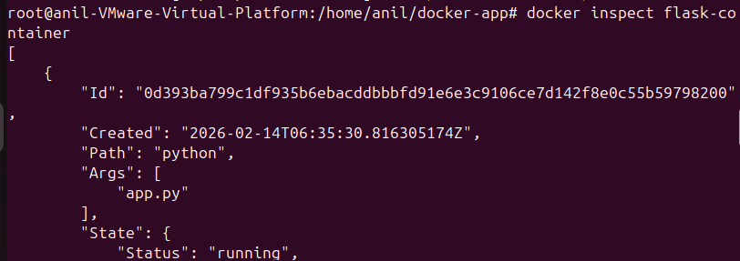
7.Stop, remove containers and images to understand cleanup.
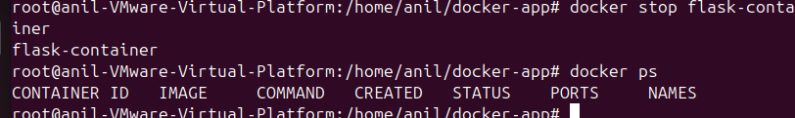
8.Document Dockerfile structure and image lifecycle.
Dockerfile structure
FROM Base image
WORKDIR working directory
COPY copyfiles
RUN install packages
EXPOSE openport
CMD run command
Image lifecycle
Dockerfile created
Image built -docker build
Container run -docker run
Stop – docker stop
Remove -docker rm
Delete image – docker rmi

